Who needs more champers? | FHB | Something smells delicious | Very thin white bread | Grace
Something smells likes it's burning | Gravy anyone? | How is Frank doing? | Anyone for coffee? | How long does the roast cook?
Save the wrappings | Scrum | 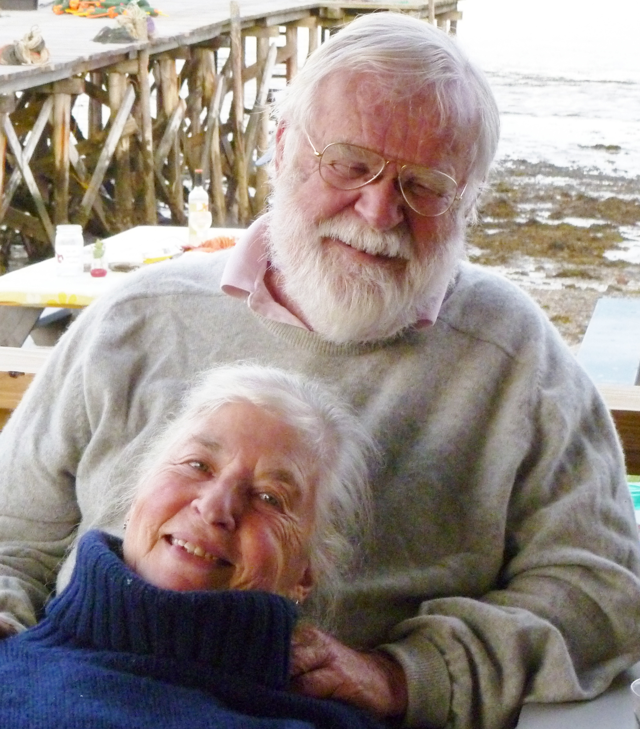 | It’s just want I’ve always wanted. | This is delicious!
Pass the wine down here please | Smaller piece! | It’s “two buck Chuck” | A little bit more please | Can I cut you another piece?
Flatter the cook, ask for seconds | Nice antlers | More pud? | An elegant sufficiency | KOD (kiss of death)

Christmas Dinner Bingo

