Save the wrappings | Anyone for coffee? | The meat’s a little___ | Whinge | Christmas crackers
It’s from TJ’s | Pass the ___ | Grace | An elegant sufficiency | Plum pudding?
FHB | Can I cut you another piece? | 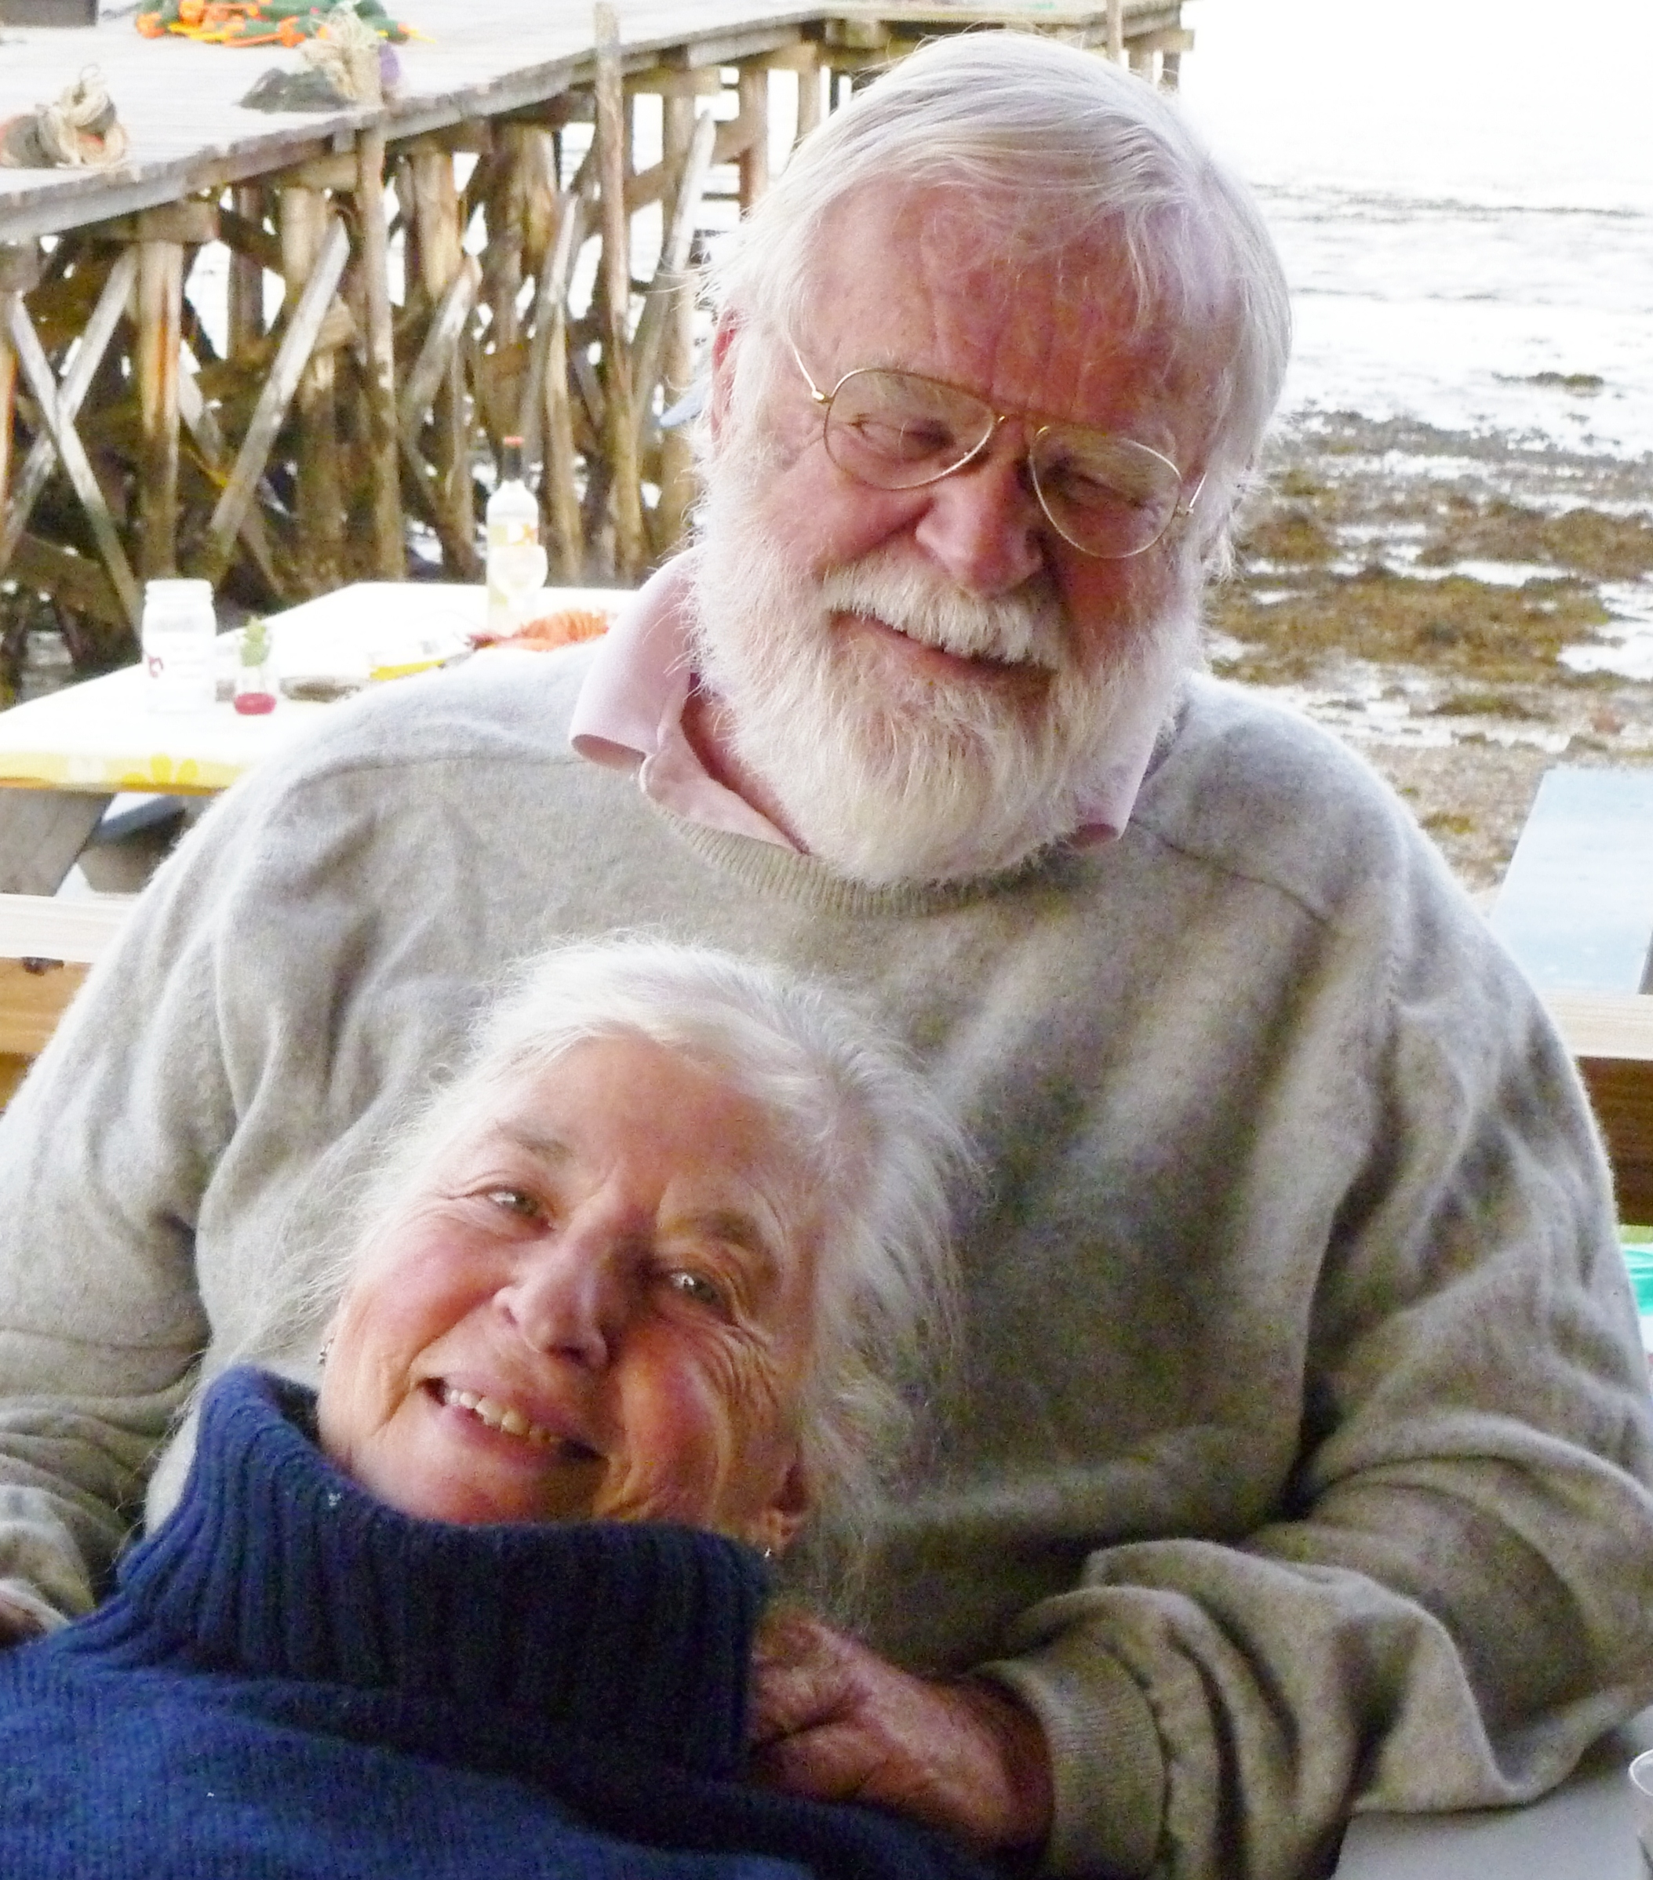 | It’s just want I’ve always wanted! | Who needs more hard sauce?
It’s the best Yorkshire pudding ever! | Smaller piece! | You couldn’t write this stuff | Very thin white bread | Who needs more champers?
I’ve been overserved | Shows lots of piss & vinegar | Flatter the cook, ask for seconds | How long does the roast cook? | Scrum

Christmas Dinner Bingo

