Pass the ___ | What time are we eating? | Pass the wine down here please | More pud? | How long does the roast cook?
How is Frank doing? | I’ve been overserved | Is that Scott playing? | Poignant | It’s from TJ’s
Something smells delicious | Gravy anyone? | 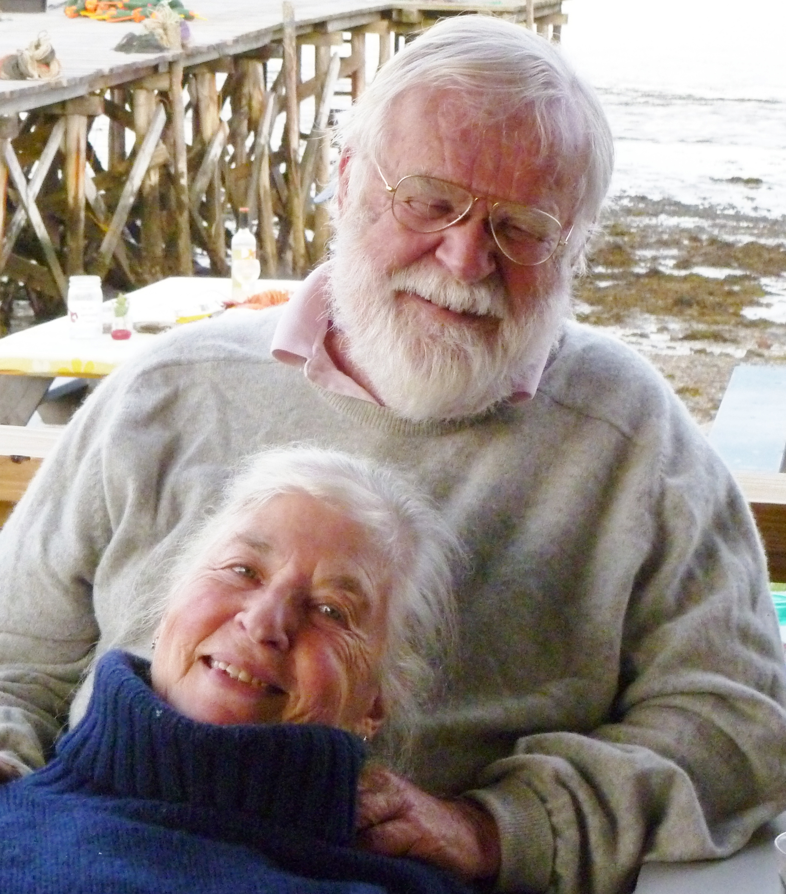 | Shows lots of piss & vinegar | Very thin white bread
Suet | You couldn’t write this stuff | Save the wrappings | Grace | Nice antlers
Is Chuck coming over? | CTD (circling the drain) | An elegant sufficiency | A little bit more please | The 3 D’s  (dirt, death & disease)

Christmas Dinner Bingo

