I’ve been overserved | An elegant sufficiency | Did you see what she was wearing? | Something smells delicious | Flatter the cook, ask for seconds
Something smells likes it's burning | Who needs more champers? | Save the wrappings | Anyone for coffee? | How long does the roast cook?
Moi | Is that Scott playing? | 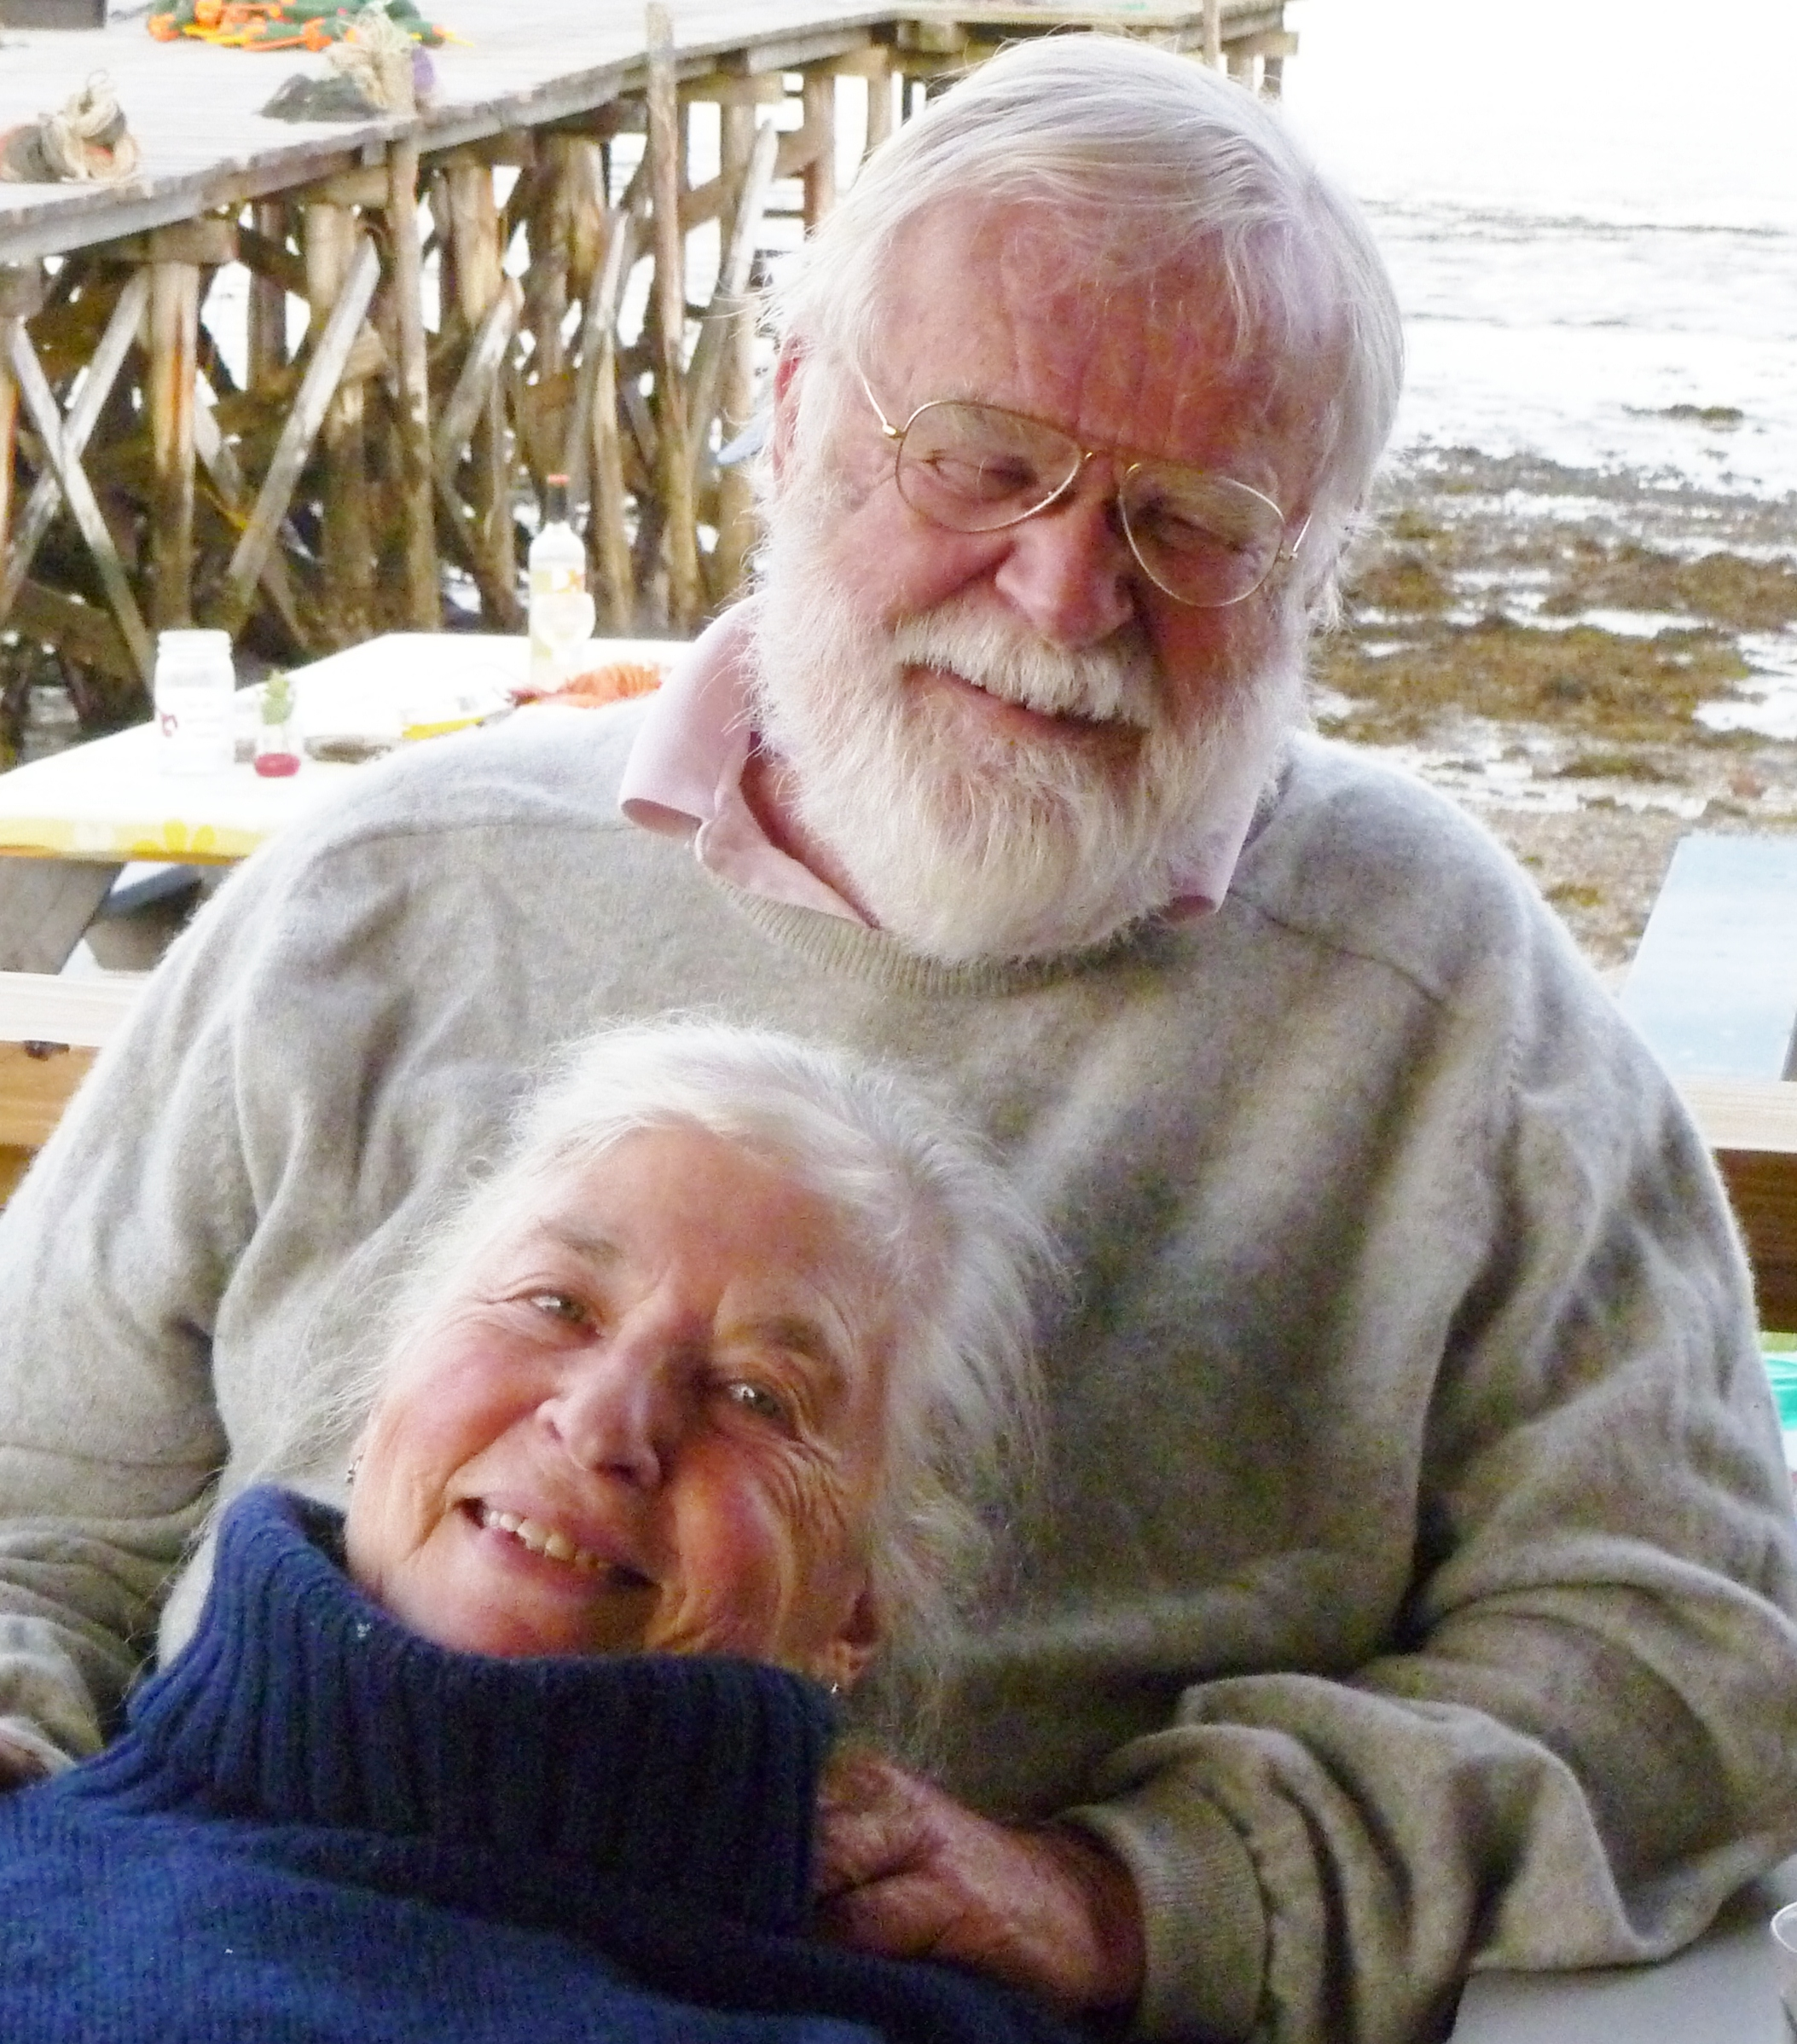 | It’s just want I’ve always wanted. | Poignant
Nice antlers | Smaller piece! | It’s the best Yorkshire pudding ever! | A little bit more please | Can I cut you another piece?
How is Frank doing? | Pass the wine down here please | It’s from TJ’s | Who needs more hard sauce? | The meat's a little___

Christmas Dinner Bingo

