Did you see what she was wearing? | Grace | Something smells delicious | Very thin white bread | How long does the roast cook?
BFD | Can I cut you another piece? | Nice antlers | I got it on sale! | Scrum
Any more…? | CTD (circling the drain) | 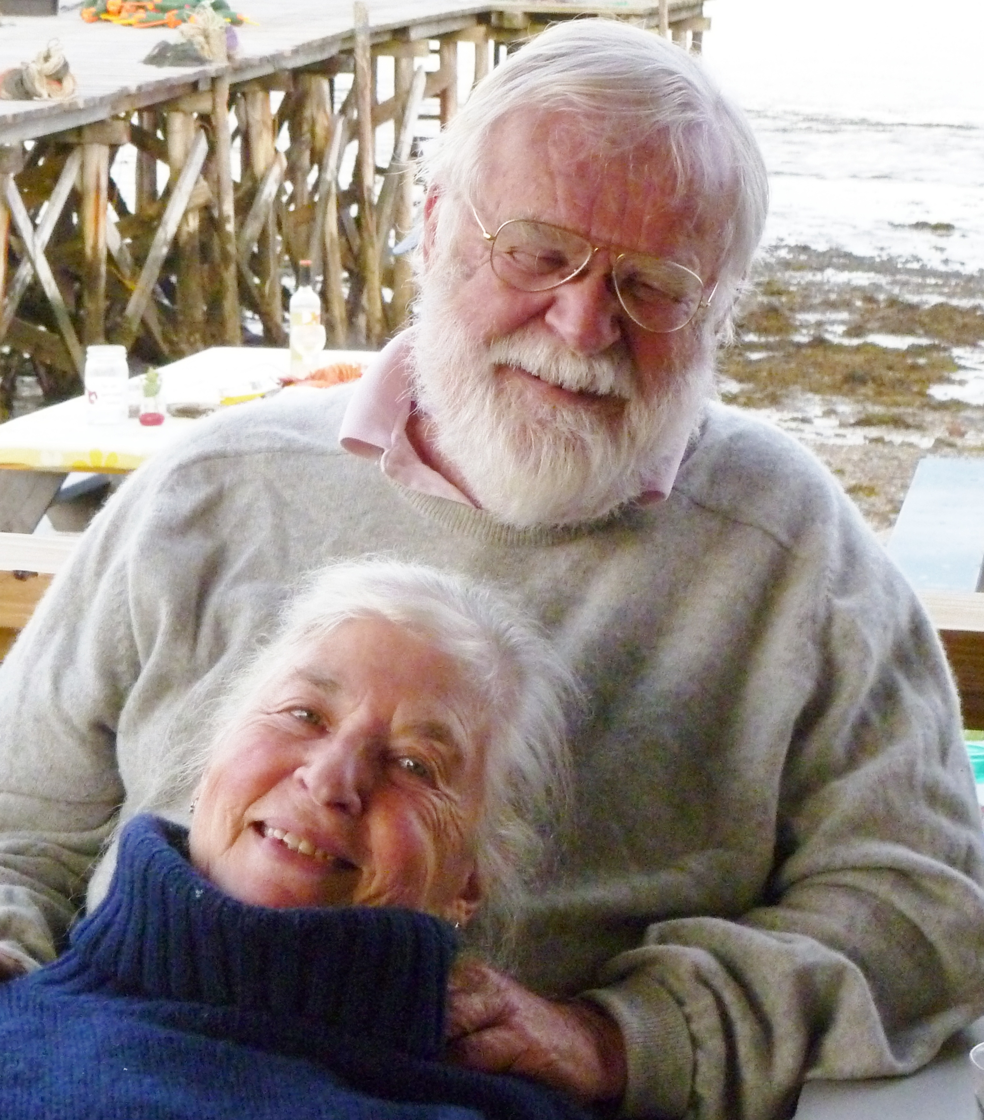 | It’s just want I’ve always wanted. | Who needs more hard sauce?
Flatter the cook, ask for seconds | Smaller piece! | An elegant sufficiency | A little bit more please | Gravy anyone?
The meat's a little___ | I’ve been overserved | Something smells likes it's burning | This is delicious! | What time are we eating?

Christmas Dinner Bingo 2009

