The 3 D’s  (dirt, death & disease) | What time are we eating? | Pass the wine down here please | Any more…? | How is Frank doing?
Whinge | I’ve been overserved | Something smells delicious | Poignant | Save the wrappings
How long does the roast cook? | Gravy anyone? | 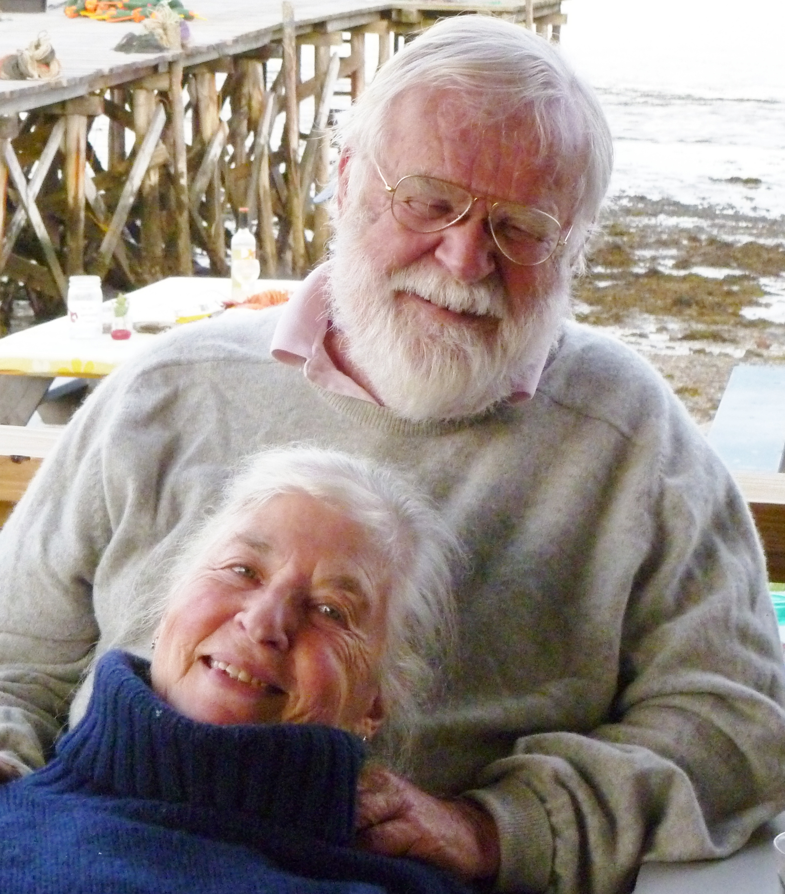 | Who needs more hard sauce? | Very thin white bread
Is that Scott playing? | Shows lots of piss & vinegar | Grace | CTD (circling the drain) | Pass the ___
Is Chuck coming over? | It’s two buck Chuck | An elegant sufficiency | A little bit more please | Something smells likes it's burning

Christmas Dinner Bingo

