Some Ideas for Strawberries
Paul’s strawberries have been so good, they don’t need messing with. When I’m not just munching them out of the box, I’ve been eating them sliced over yogurt in the morning and sliced over vanilla ice cream for dessert.
- Grill them. Either cut them in half and put in a lightly oiled grilling pan, or skewer them and brush with a light vegetable oil. Grill over medium heat until grill marks start to show and the berries are warm, about 5 minutes. Serve with ice cream or Greek style yogurt.
- Make your own crème fraiche, it’s super easy. In a glass container mix together: 1 cup of heavy cream and 2 tablespoons buttermilk. Cover (a dishtowel is fine) and let stand on the counter overnight (or up to 24 hours). When it’s fairly thick, refrigerate until ready to serve. It will thicken up when chilled.
- Try strawberry shortcake with buttermilk biscuits and use vanilla ice cream instead of whipped cream. Slice the berries and toss with a tablespoon or two of sugar to release their juices.
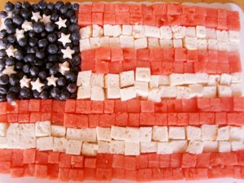
- For a festive July 4th dessert, mix strawberries, blueberries and chunks of angel food cake. Serve with toothpicks and everyone can make their own mini-skewers. To keep with the patriotic theme, how about a white chocolate fondue? In a large saucepan over medium high heat combine ½ stick of unsalted butter and a cup of heavy cream. Bring to a simmer, stirring constantly. Stir in two 12 ounce packages of white chocolate bits until melted and smooth. Transfer to a fondue pot or ceramic bowl. Serve and enjoy. Here’s a fun way of serving the berries and angel food cake (I used watermelon because I ate all the strawberries):

